



**SOFTWARE ENGINEERING PROJECT Term : Sept 2023 - Dec 2023**

**Milestone - 3**

**Contributors:**

**JS Ranjith (21f1002171)**

**Mohd. Ikram (21f2000712)**

**Dhruv Gupta (21f1004011)**

**Bimlesh KR Kanth (21f1005524)**

**Rahul Chakraborty (21f1002786)**

**Sprint Schedule:**

|  |  |
| --- | --- |
| **Sprint** | **Duration** |
| 1. Requirement Gathering and Designing | 01/10/2023 to 10/10/2023 |
| 1. Project Scheduling and Designing | 15/10/2023 to 24/10/2023 |
| 1. Application Development | 31/10/2023 to 14/11/2023 |
| 1. Application Testing | 15/11/2023 to 24/11/2023 |
| 1. Final Submission | 25/11/2023 to 30/11/2023 |

|  |  |  |
| --- | --- | --- |
| **Meeting Type** | **Day** | **Time** |
| Daily Stand-up call | Monday-Friday | 9:30 PM |
| Backlog Refinement Call | Monday | 9:30 PM |
| Sprint Planning Call | Wednesday | 9:30 PM |
| Sprint Retrospective call | Monday | 9:30 PM |
| Sprint Review | Tuesday | 9:30 PM |

**Scrum Meeting Schedule:**

**Few important Minutes of Meeting:**

|  |  |  |
| --- | --- | --- |
| **Date** | **Meeting Type** | **Description** |
| 2/10/2023 | Daily Stand-up | Github accounts to be update, Jira account to be created for collaboration |
| 4/10/2023 | Sprint Planning | Work distribution among team members. Ikram will be creating the data base design and implementation, Rahul, and Dhruv will be creating Wireframes, Bimlesh/Ranjith will make user-stories, and storyboard |
| 9/10/2023 | Backlog Refinement | Discussion about the progress made in the tasks allocated. |
| 11/10/2023 | Daily Stand-up | Discussion of Sprint 2 |
| 10/10/2023 | Sprint Review | Meeting to give the final touches to the final submission, updating honor code and submission of milestone 1 |
| 18/10/2023 | Sprint Planning | Task allocation for the project. Ranjith will be building Storyboard and python tests for 4 of the wireframes, Dhruv will be taking care of the minutes of meeting, Rahul will be working on the report, Ikram will be working on database design schema |
| 24/10/2023 | Sprint Review | Team reviewed the work done under sprint 2. |

**Members of Jira workspace:**

|  |  |
| --- | --- |
| **Acronym** | **Names** |
| **MI** | **Mohd Ikram** |
| **RC** | **Rahul Chakraborty** |
| **BK** | **Bimlesh KR Kanth** |
| **JR** | **JS Ranjith** |
| **DG** | **Dhruv Gupta** |

**Scheduled Upcoming Tasks Under Sprints:**

**Sprint 3 (Application Development ):**

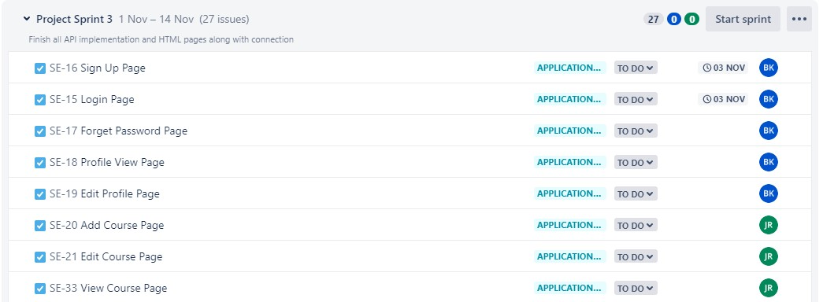

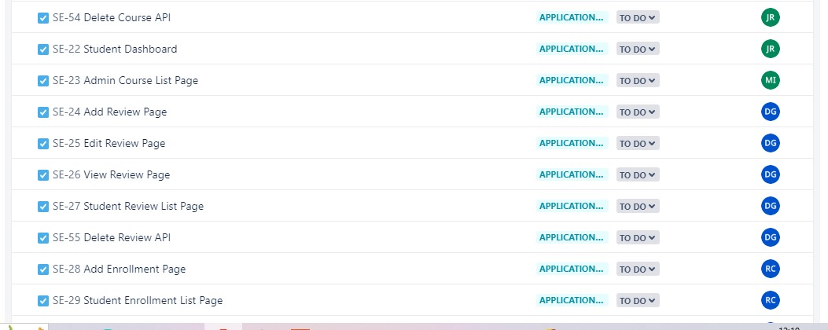

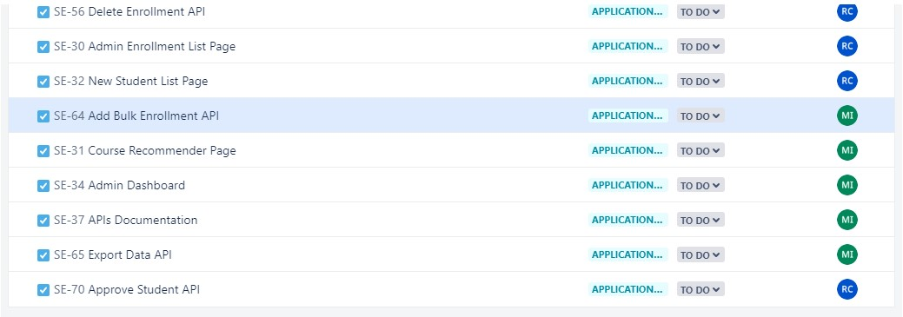

**Sprint 4 (Application Testing):**

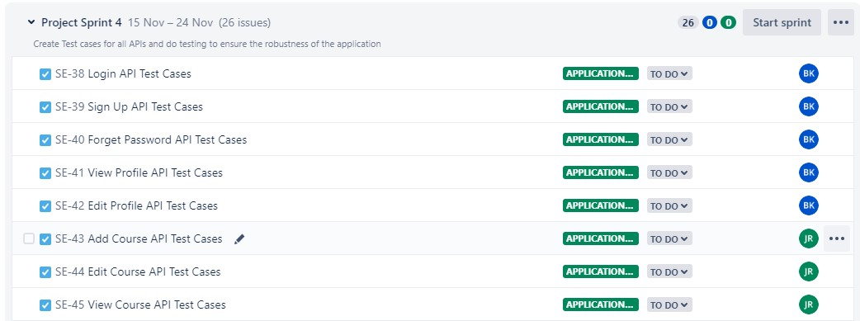

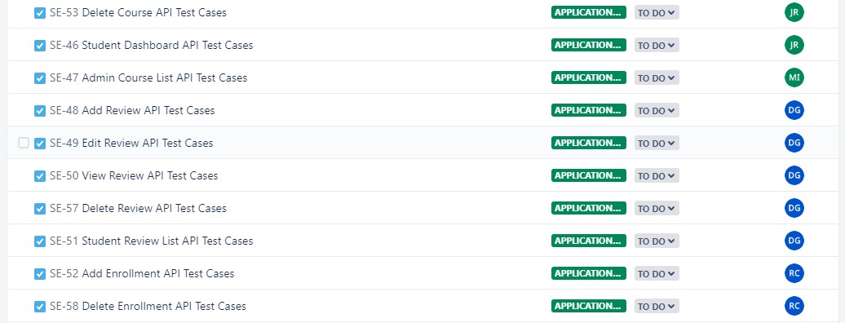

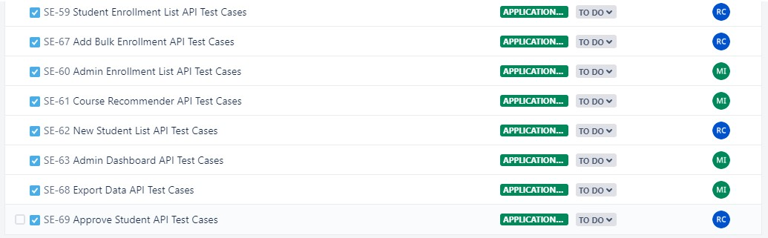

**Sprint 5 (Final):**

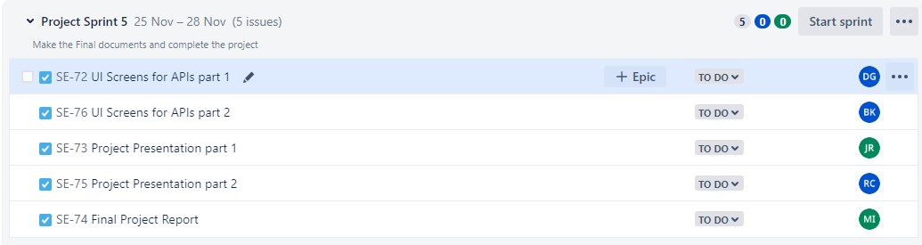

**Gantt Chart:**

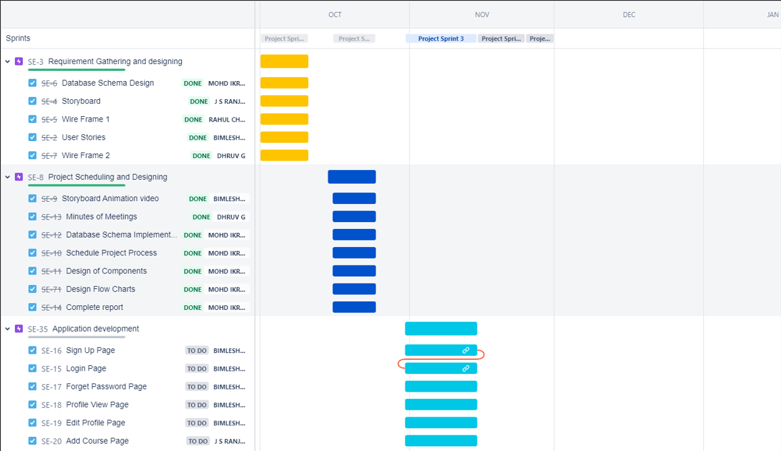

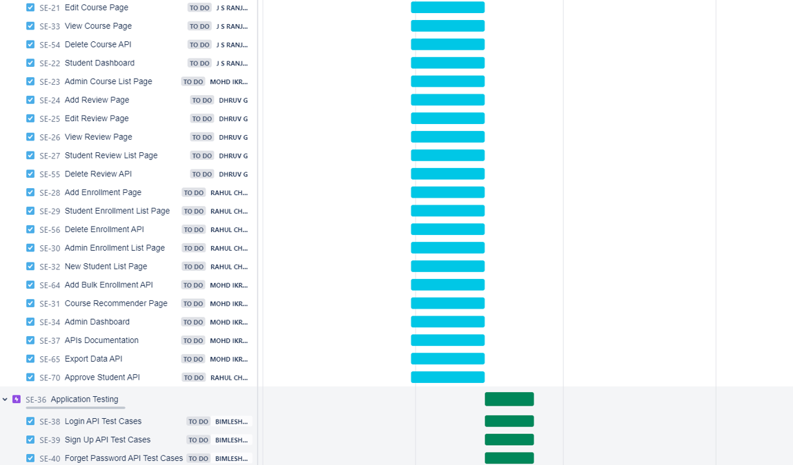

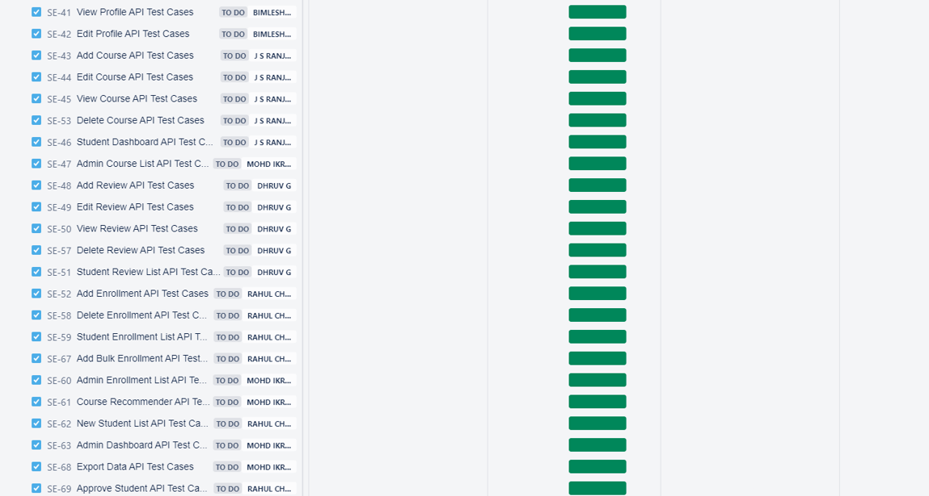

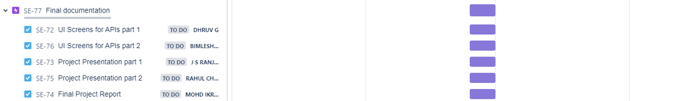

**Design Of Components:**

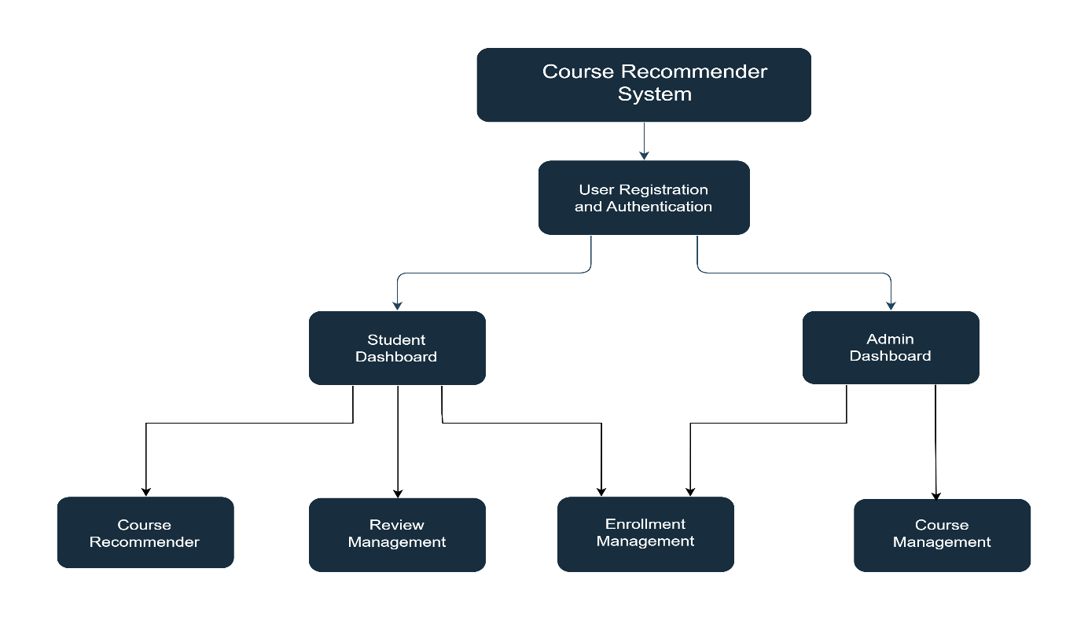

**Class Diagram:**

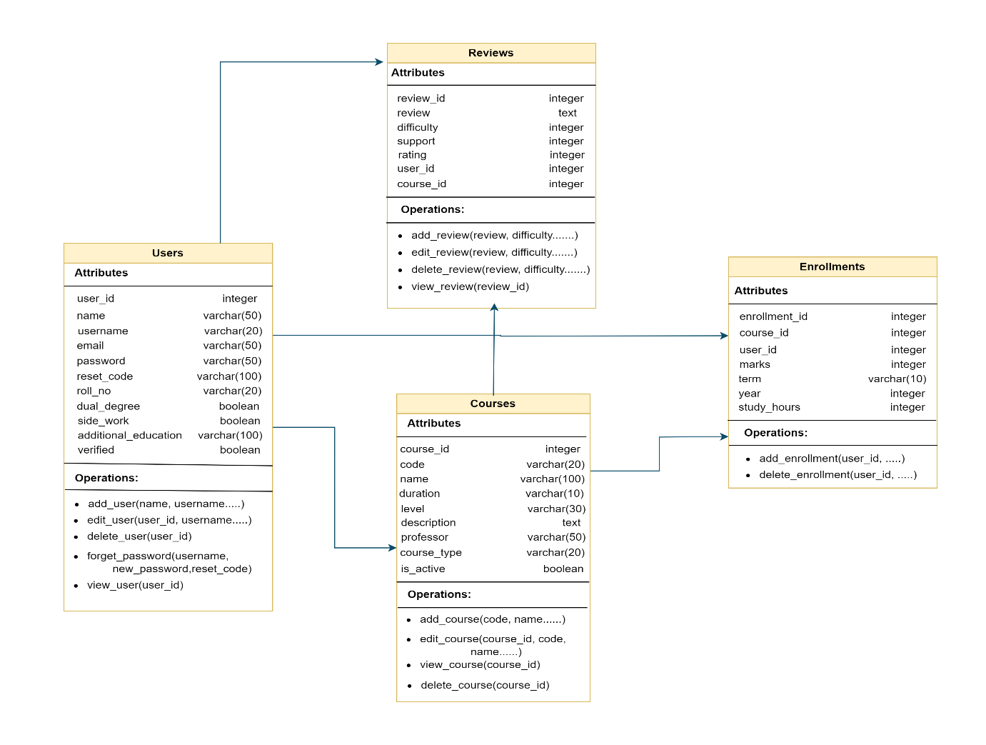

**Database Schema:**

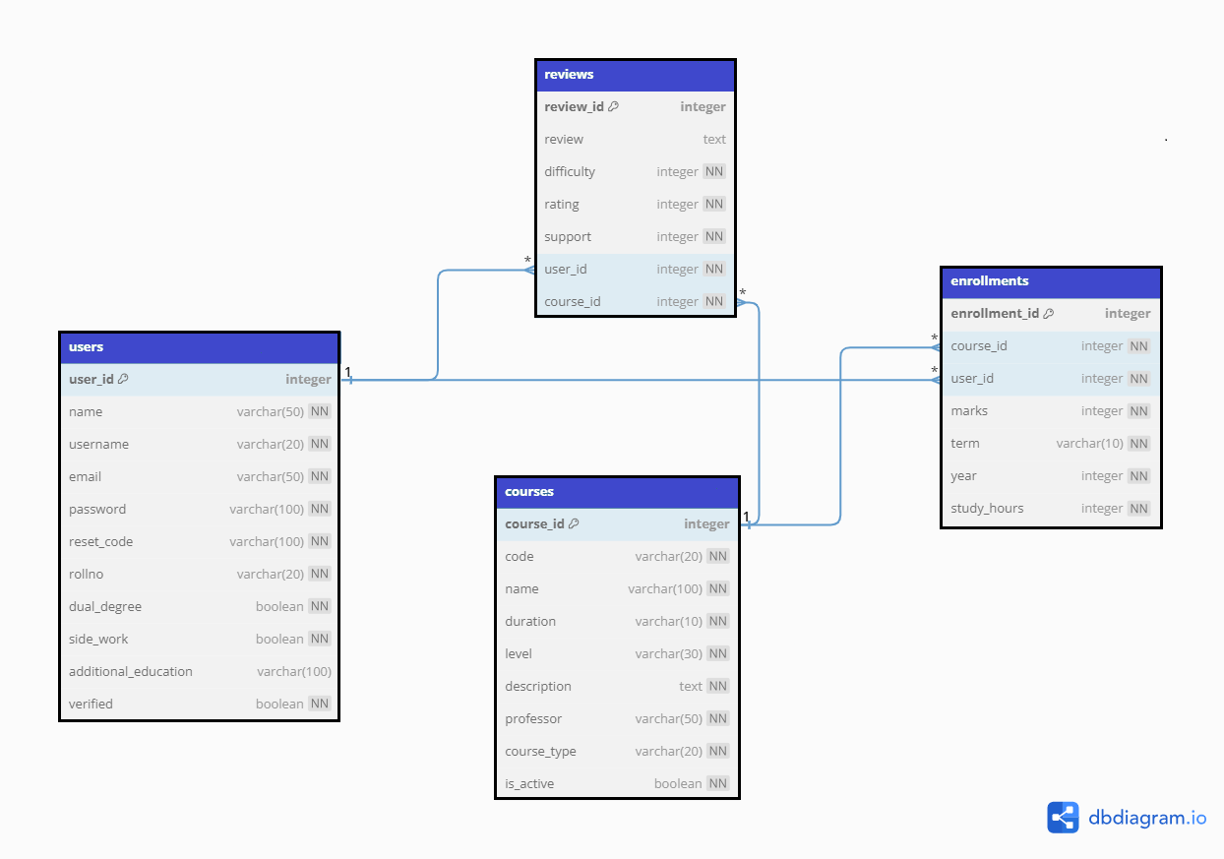

**Flowcharts:**

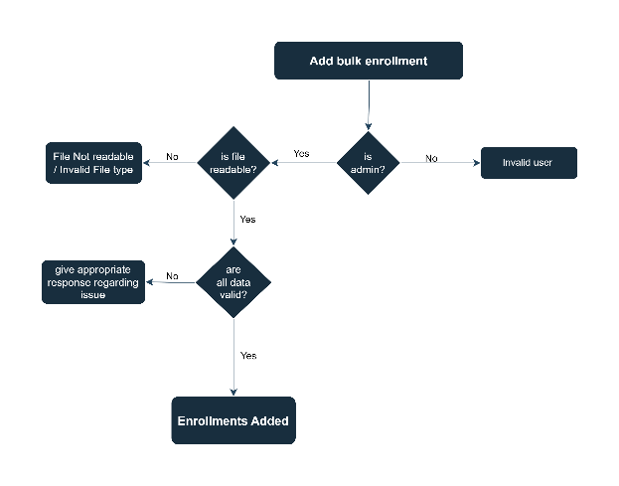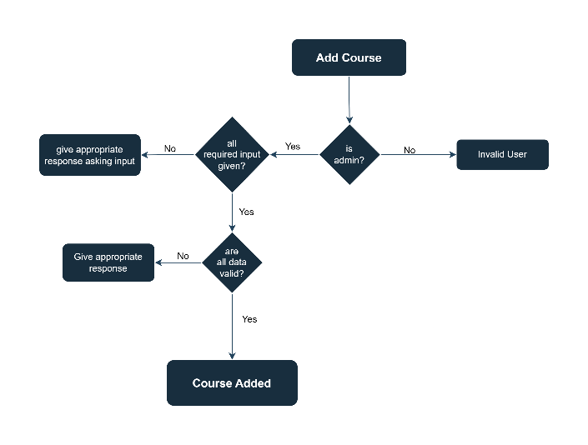

Add Bulk enollment Add Course

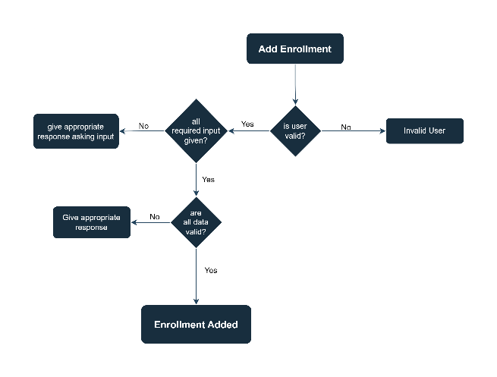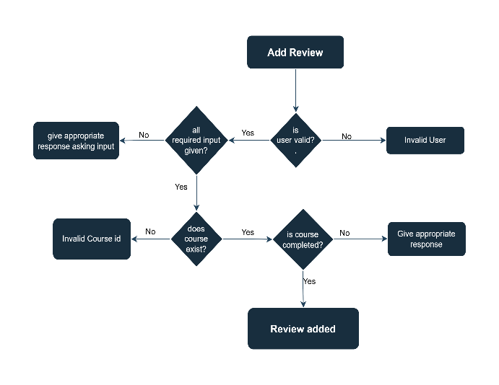

Add Enrollment Add Review

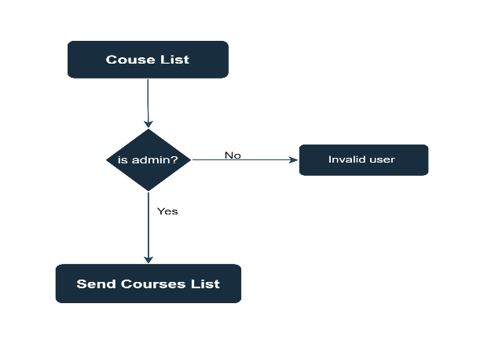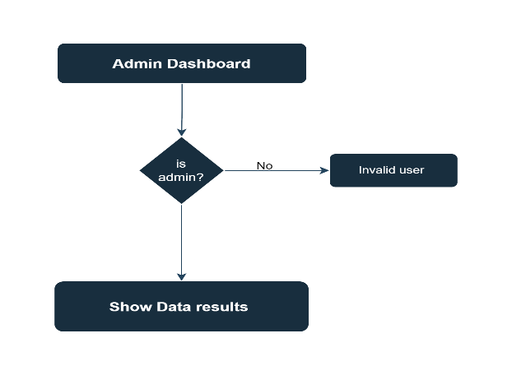

Course List Add Dashboard

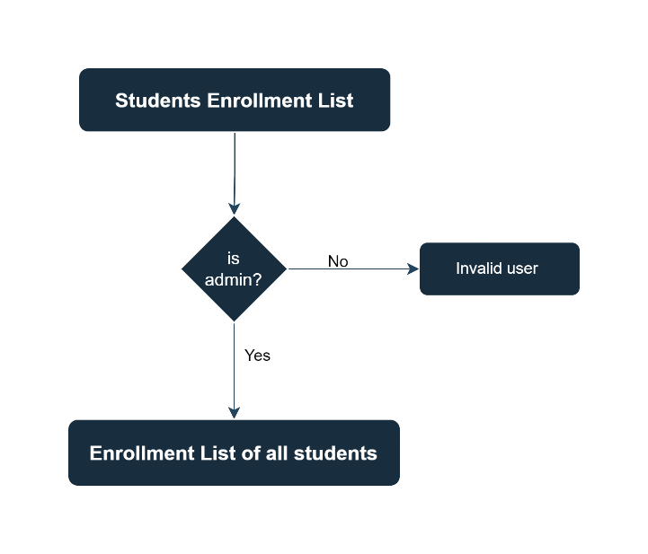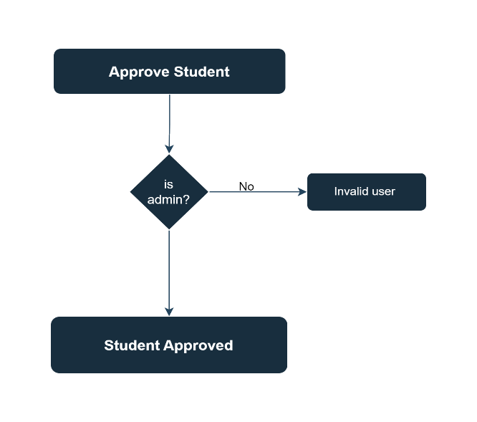

Admin Students Enrollments Approve Student

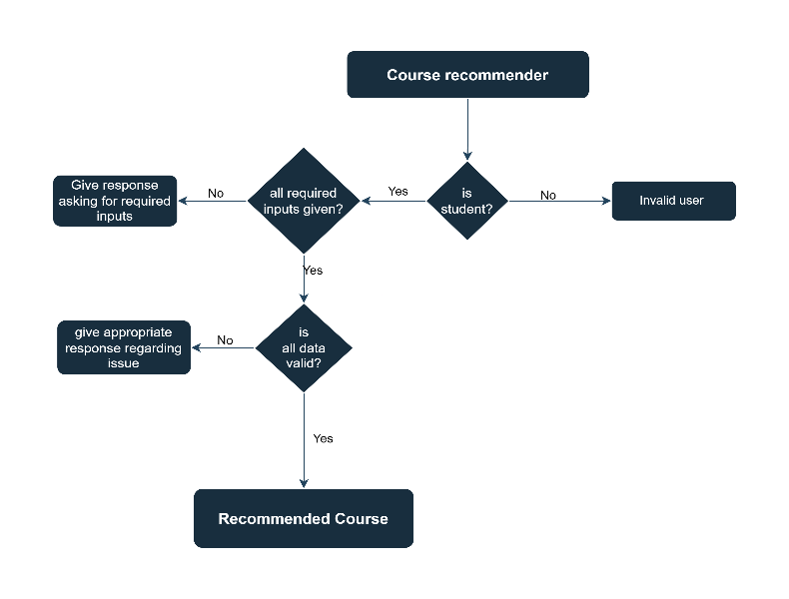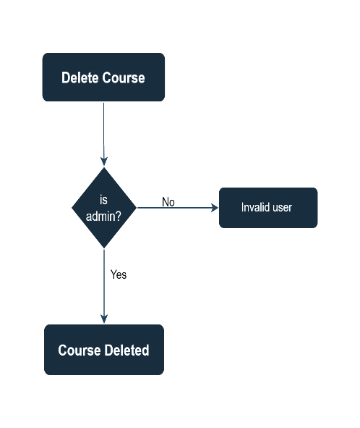

Course Recommender Delete Course

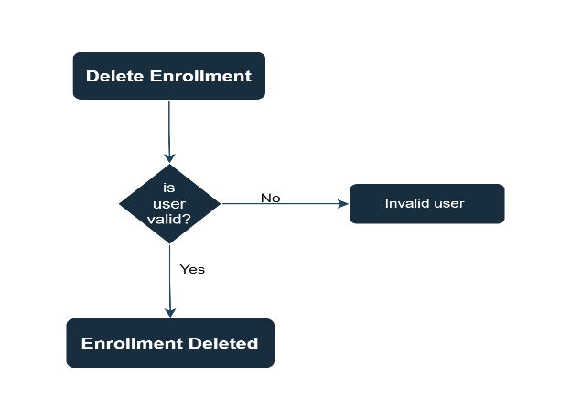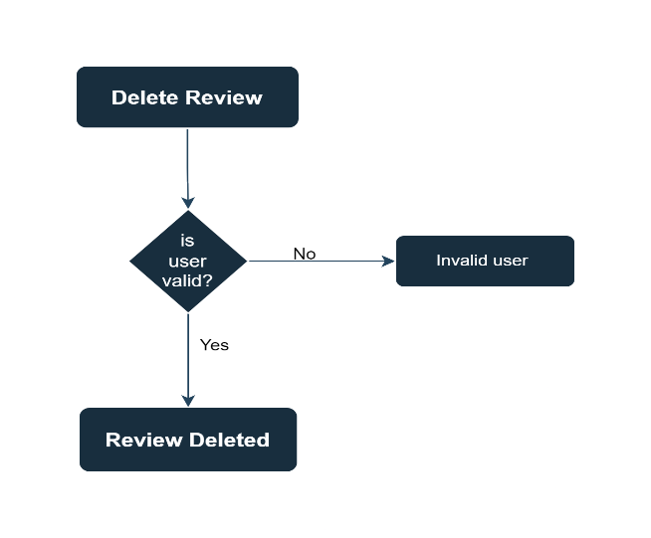

Delete Enrollment Delete Review

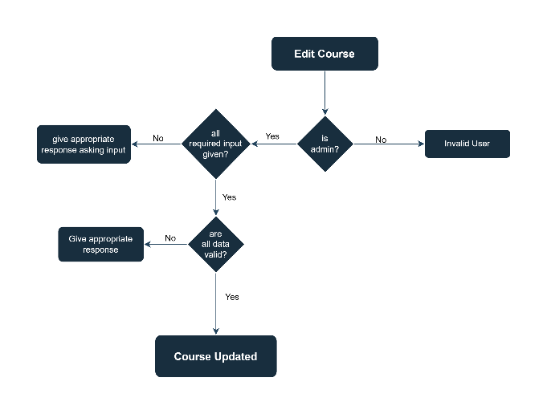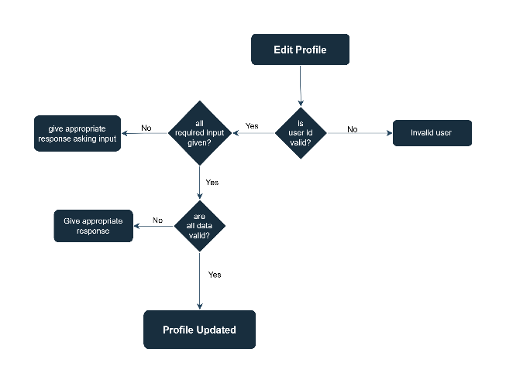

Edit Course Edit Profile

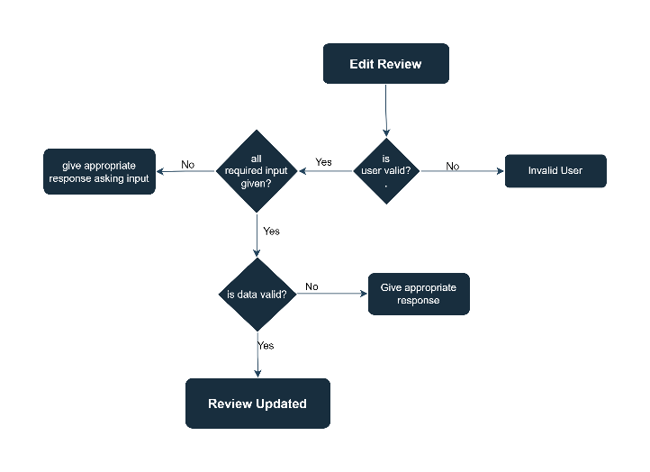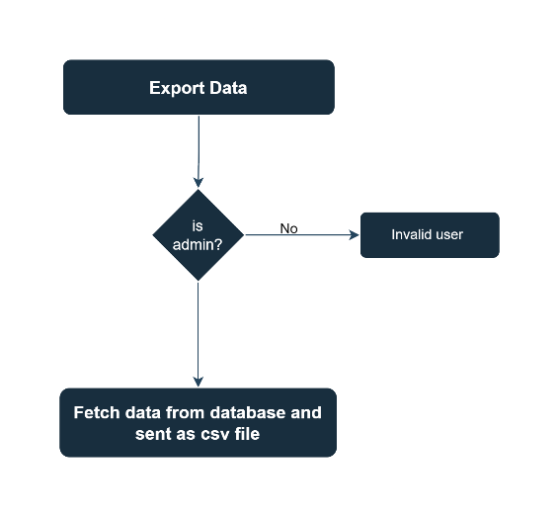

Edit Review Export Data

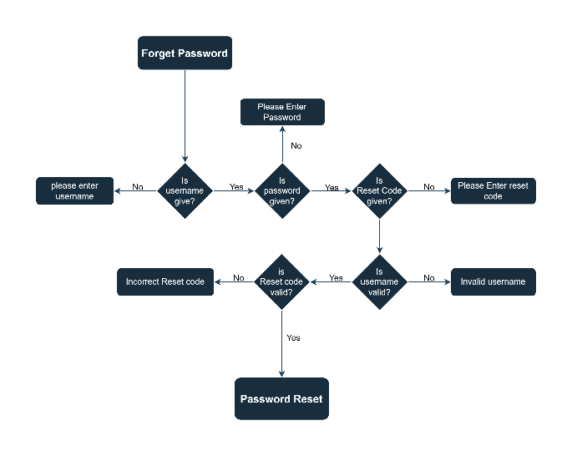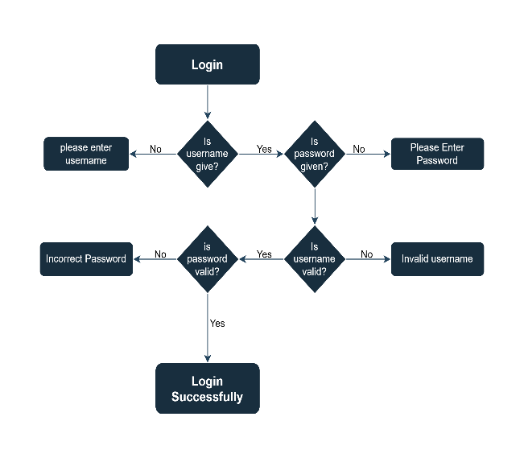

Forget Password Login

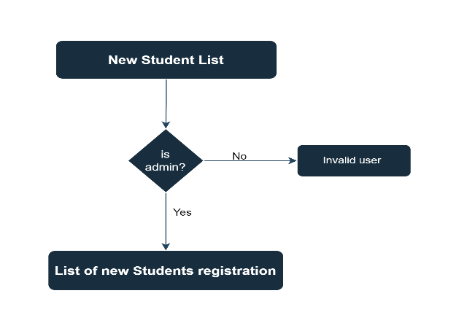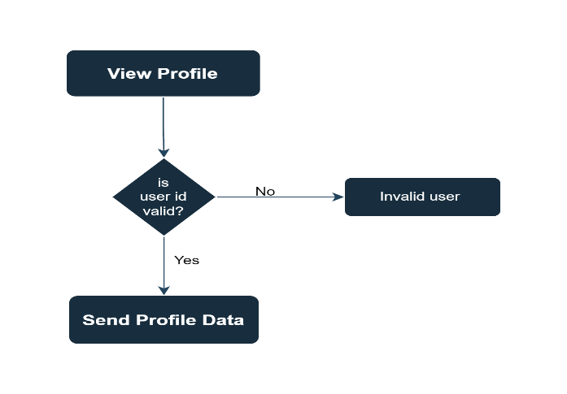

New Students List View Profile

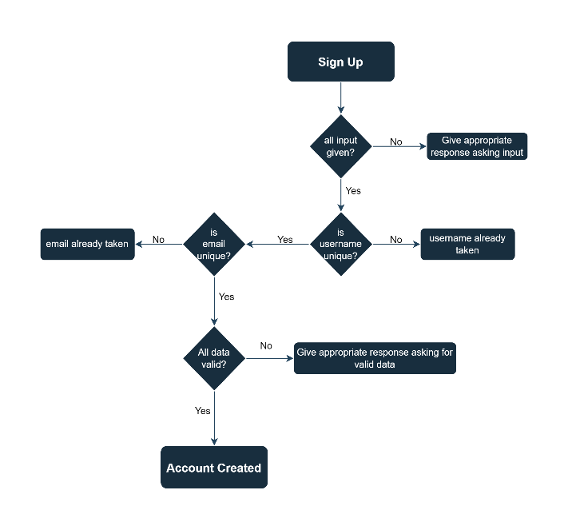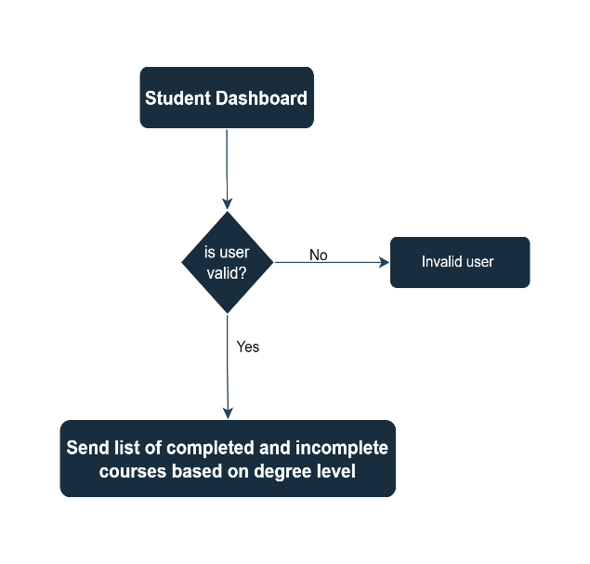

Sign Up Student Dashboard

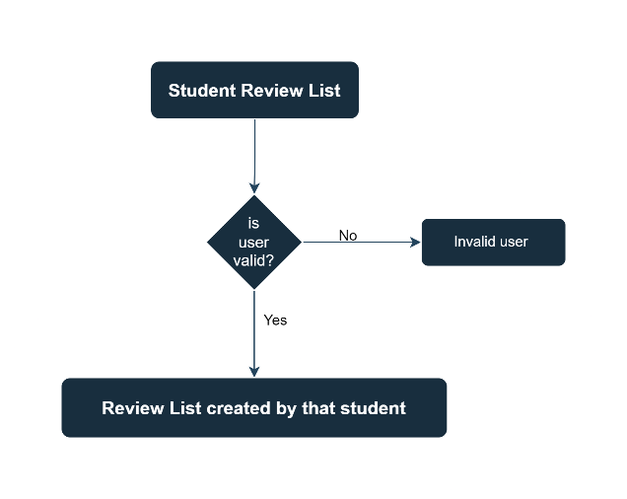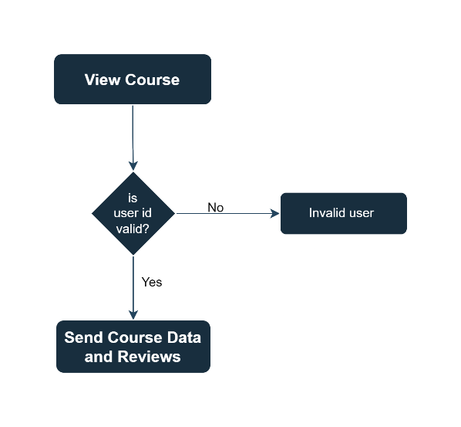

Add review View Course

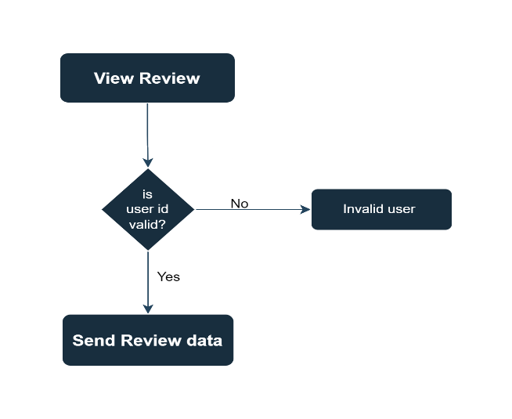

View Review